
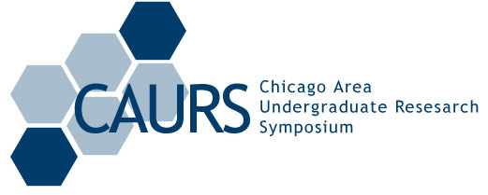

The First-Annual
Chicago Area Undergraduate Research Symposium

to be held on
Saturday April 23, 2005
in downtown Chicago at
Kellogg School of Management Conference Center

Events include:
Student Poster Session
Undergraduate Research Presentations
Career Forum
Professional Lectures

Cash awards for participants!

in collaboration with University of Chicago, Loyola, University of Illinois at Chicago
hosted by Northwestern University

Registration and abstract submission at:
www.caurs.com

